**TOP VENT**

AIR CONDUCTOR REAR

AIR CONDUCTOR FRONT

**PINLOCK PIN**

**VISOR LOCK**

**BROW VENT**

**REAR VENT**

**HOLDER (SIDE POD)**

**CHIN VENT**

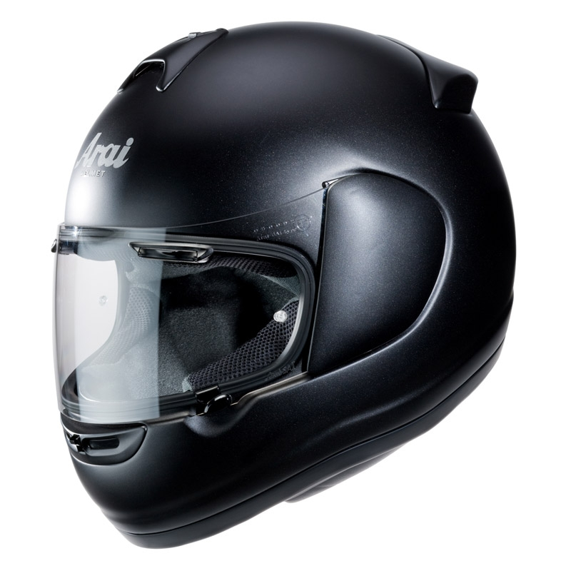

**BREATH GUARD**

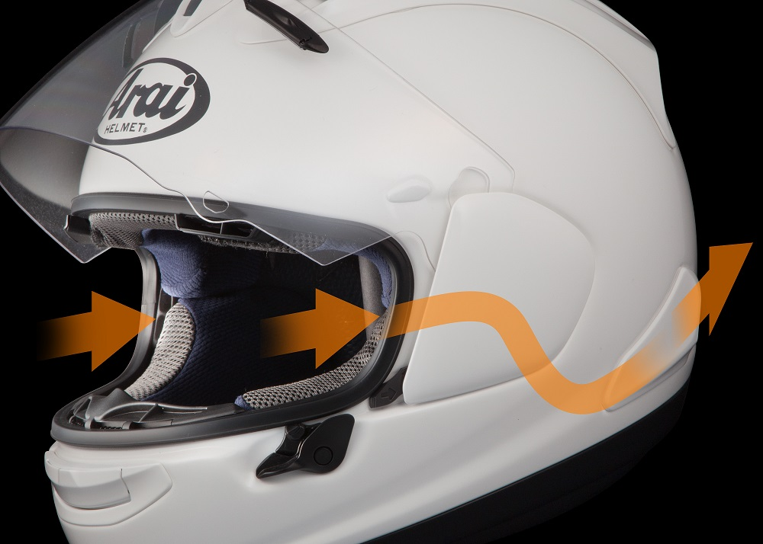

DELTA DUCT

**REAR WING**

**RX-7 SPECIFIC**

**DIFFUSER SET**

**TOP VENT**

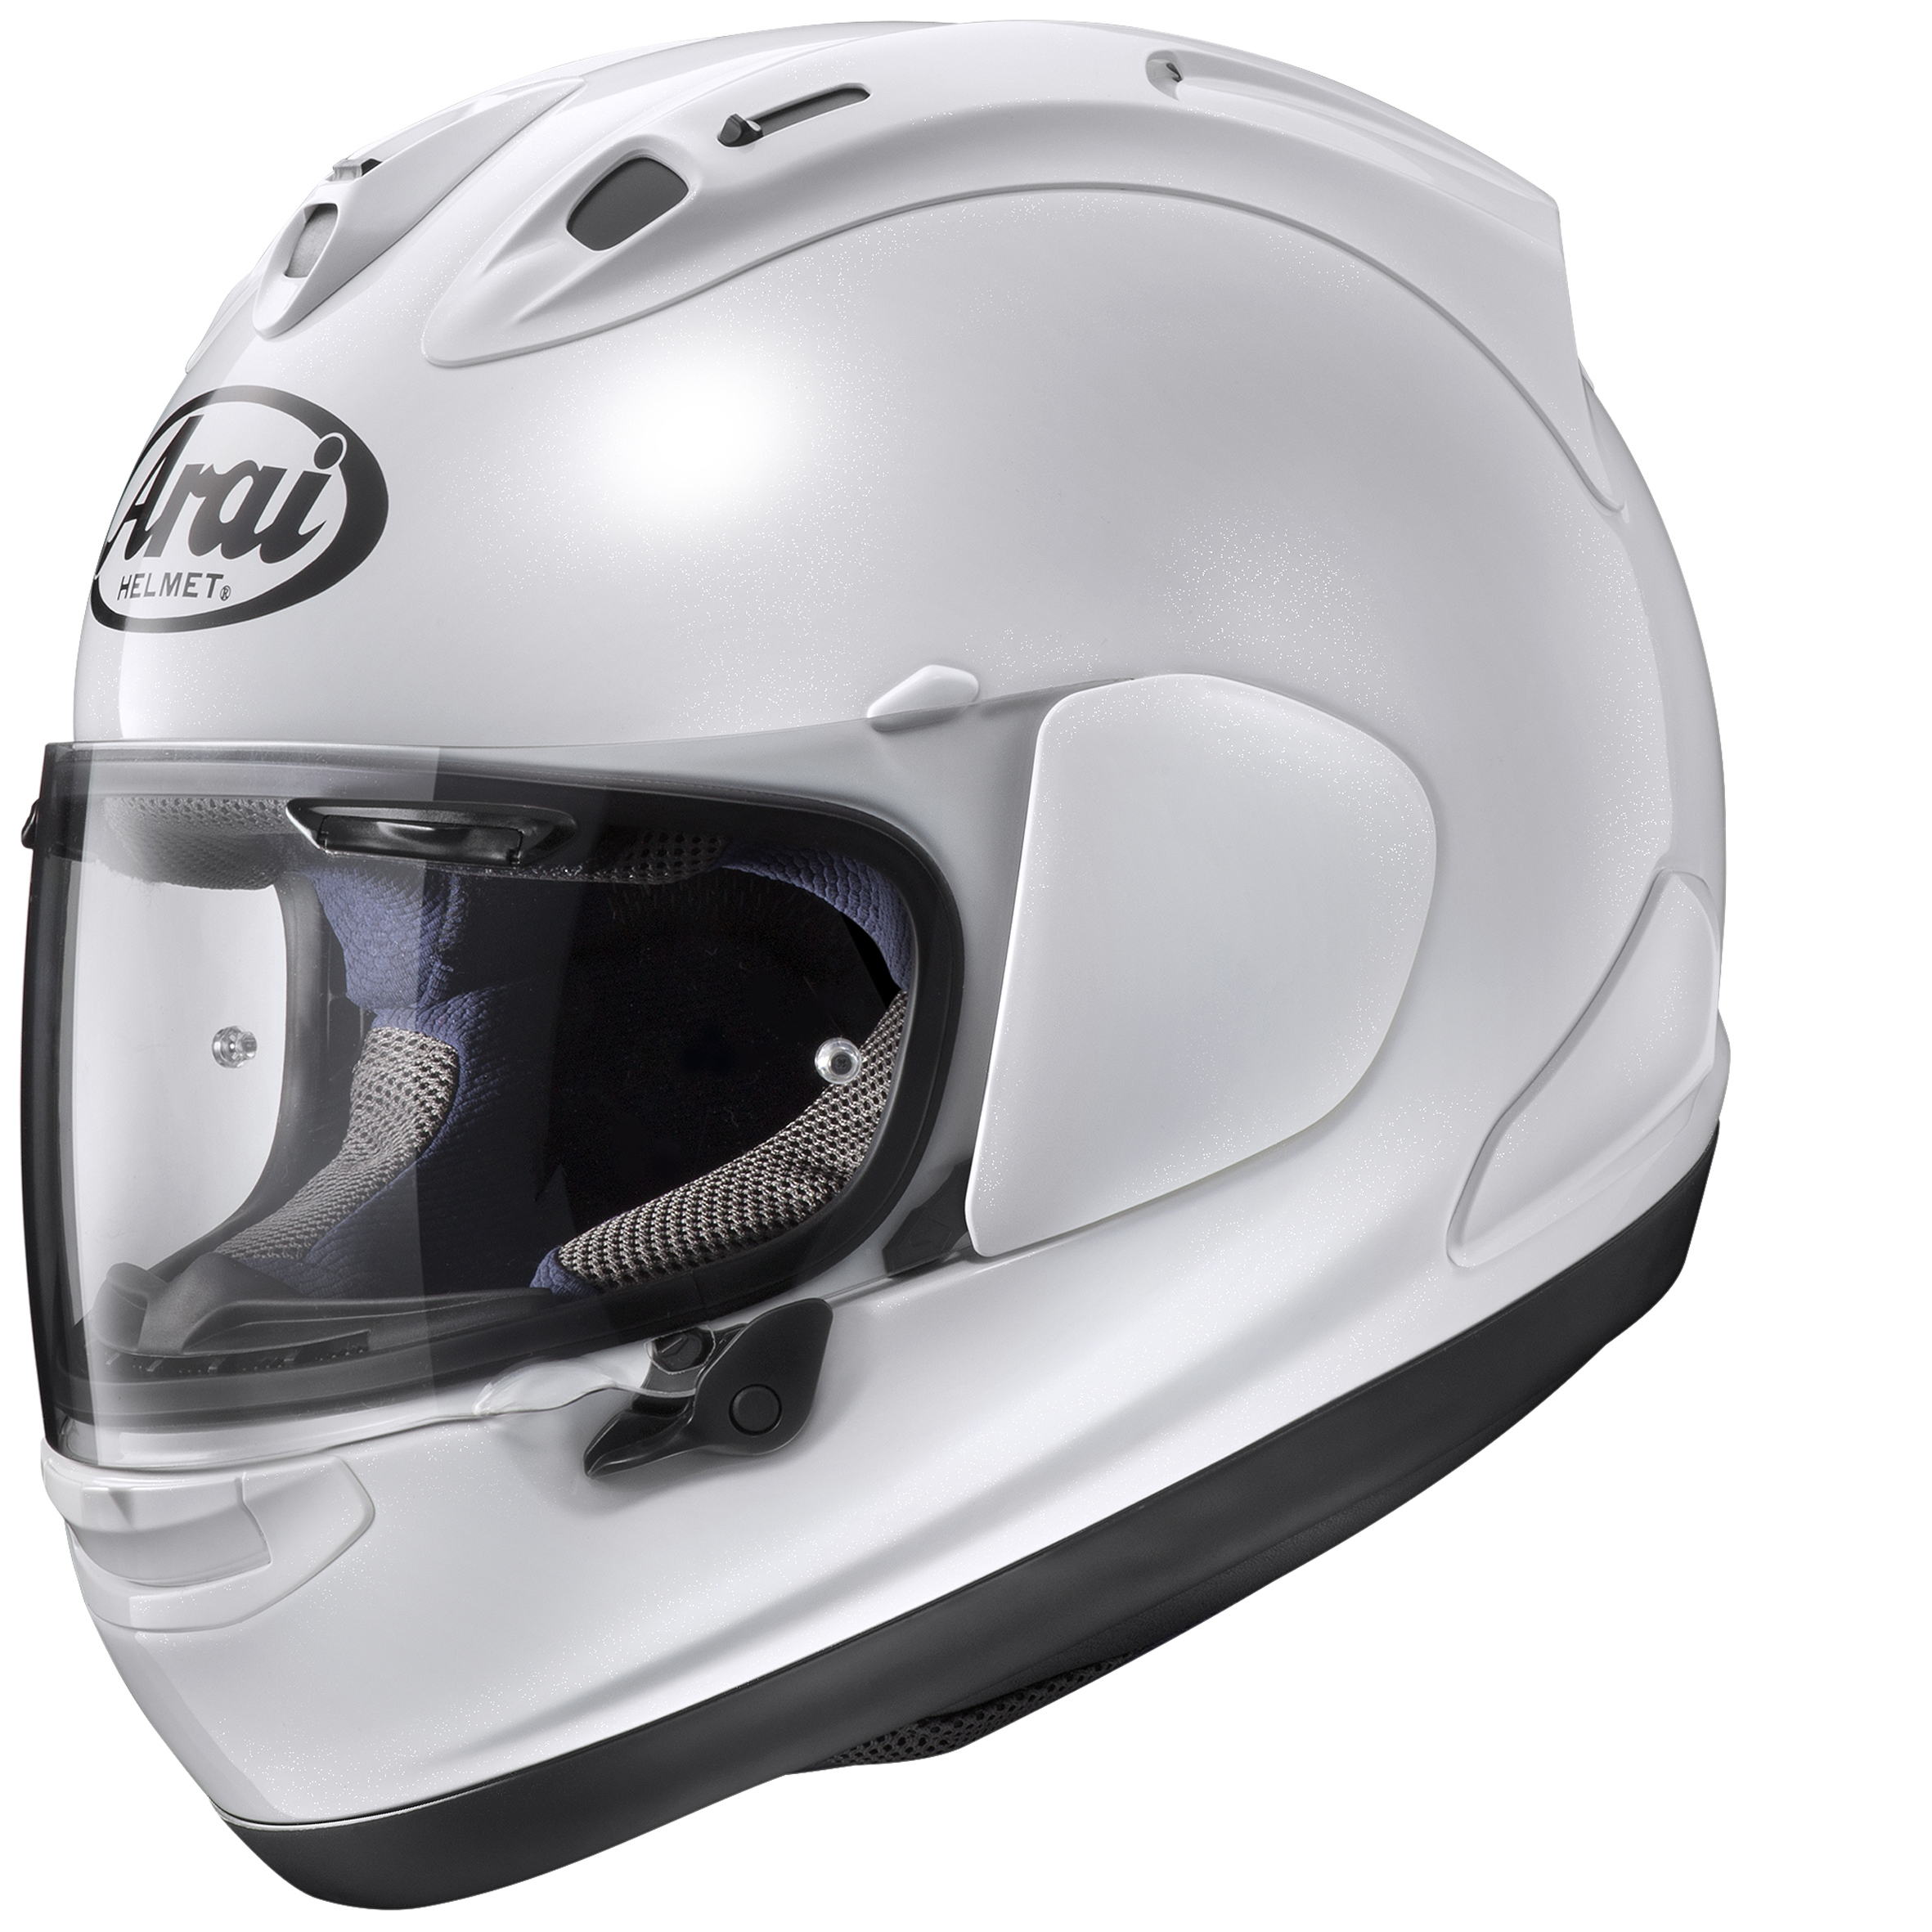

INTERIOR PAD

**CROWN LINER**

**CHEEK PAD**

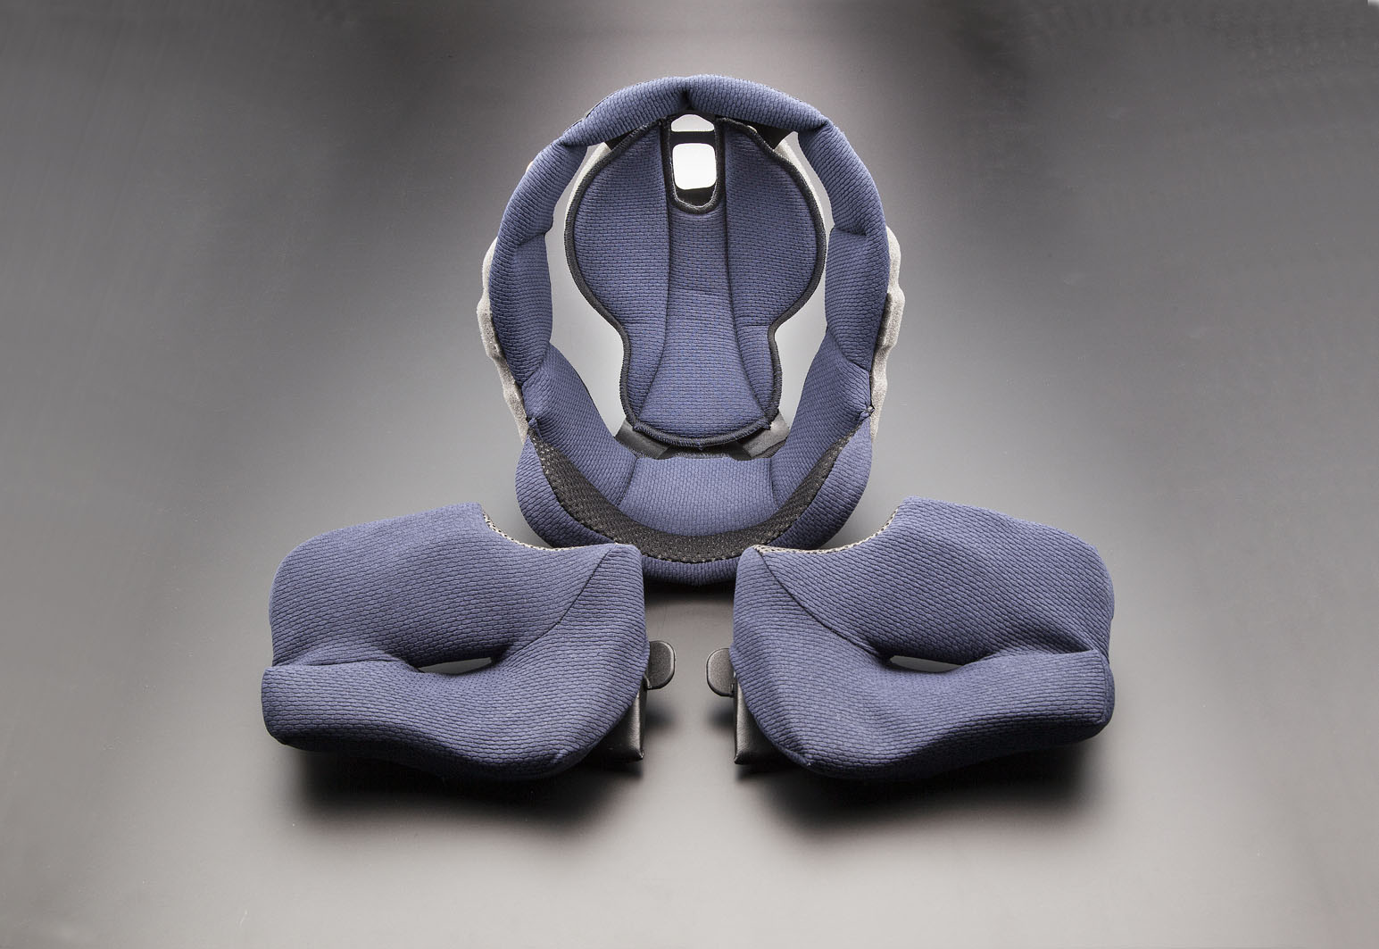

**CHIN STRAP COVER**

**NECK ROLL**

